Part E: Network Connection Diagnosing Flowcharts
(all 3 charts are present in the diagram)
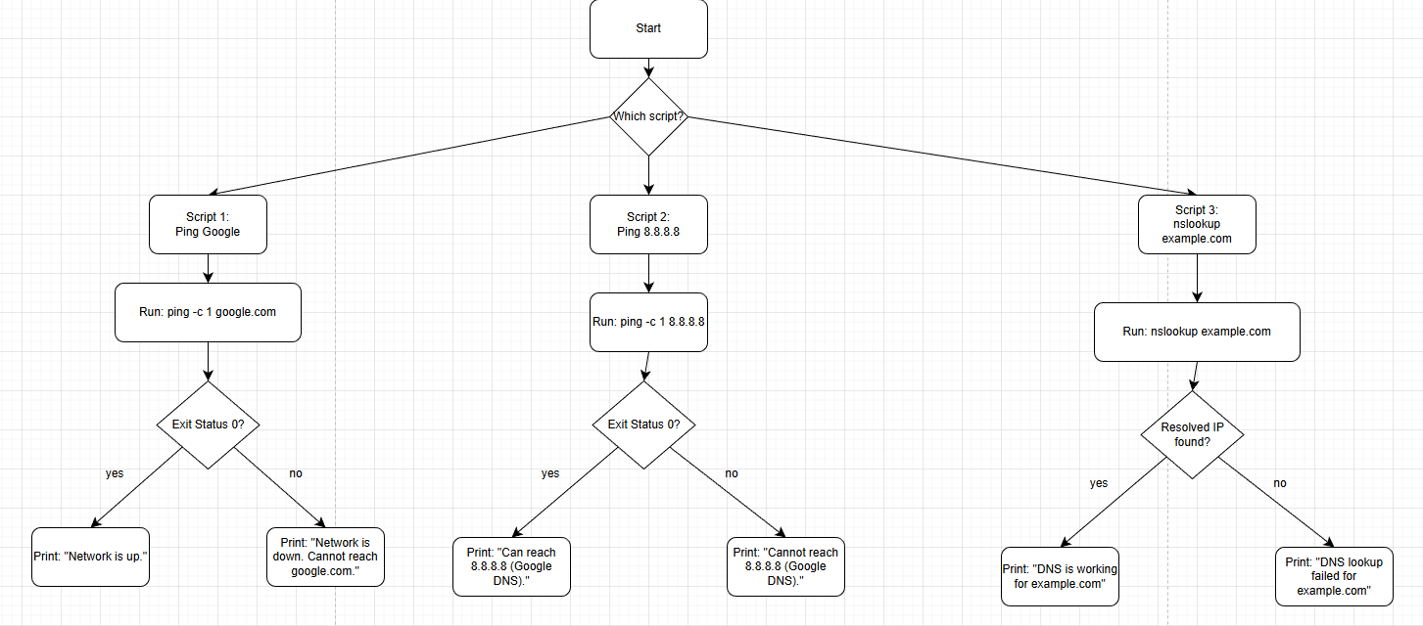
Note for evaluators:
Forget to mention in some videos that I had to make files executable as one of the steps using chmod since the files were already executable when I was recording.
Examples:
chmod +x install_vim.sh
chmod +x create_user.sh
chmod +x delete_user.sh

PART I: Sources
Free Software Foundation. (2023). Bash reference manual. https://www.gnu.org/software/bash/manual/
Kerrisk, M. (Ed.). (2024). Linux man-pages project. https://www.kernel.org/doc/man-pages/
Linux Foundation. (2023). Introduction to Linux. https://training.linuxfoundation.org/resources/free-courses/introduction-to-linux/
Red Hat, Inc. (2024). Red Hat Enterprise Linux documentation. https://access.redhat.com/documentation/en-us/red_hat_enterprise_linux/

